**Project Identification**

|  |  |
| --- | --- |
| **Project:** | AI Integrated Inventory Management System |
| **Prepared By:** | Gorkem SARI  Jaqueline DUARTE  Valunchanut SIMAROJ  Igor OLIVEIRA |
| **Document Version:** | 1.0 |
| **Published Date:** | October 1st 2023 |

**Contributors**

The following individuals contributed to this document.

| **Name** | **Title** |
| --- | --- |
| Gorkem SARI | Team Member |
| Jaqueline DUARTE | Team Member |
| Valunchanut SIMAROJ | Team Member |
| Igor OLIVEIRA | Team Member |

**Distribution**

This document is distributed to all the following people.

| **Name** | **Title** |
| --- | --- |
| Gorkem SARI | Team Member |
| Jaqueline DUARTE | Team Member |
| Valunchanut SIMAROJ | Team Member |
| Igor OLIVEIRA | Team Member |

**Referenced Documents**

This document refers to the following materials

|  |  |  |  |  |
| --- | --- | --- | --- | --- |
| **Version number** | **Title** | **Author** | **Date** | **Source / Location** |
|  |  |  |  |  |
|  |  |  |  |  |
|  |  |  |  |  |

**Revision History**

|  |  |  |  |
| --- | --- | --- | --- |
| **Version Number** | **Revision Date** | **Summary of Changes** | **Modified by** |
| 0.1 | September 21st | Input necessary information | Gorkem Sari |
| 1.0 | October 1st | Modified Business Context Diagram | Valunchanut Simaroj |
|  |  |  |  |

[Note: It is recommended that drafts be numbered 0.1 to 0.9, and that the first approved version be numbered 1.0. Thereafter, new version numbers will depend upon changes: 1.01, 1.1, etc for minor updates, 2.0, 3.0 etc for major changes.]

TABLE OF CONTENTS

1. Business Context Diagram 4
2. Requirements Scope Statements 4
3. High Level Business Requirements Sign-Off 4
4. Business Context Diagram

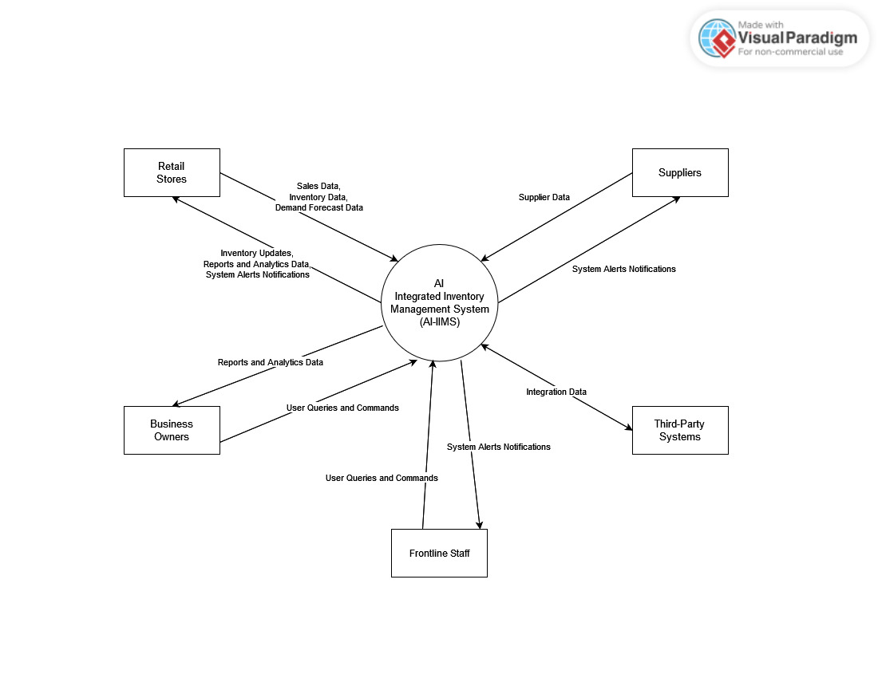

|  |  |
| --- | --- |
| **Requirement Scope Area** | **Description** |
| AI Integrated Inventory Management System (AI-IIMS) | Area responsible for providing insights for inventory management |

|  |  |
| --- | --- |
| **External Entity** | **Description** |
| Retail Stores | Represents the retail establishments that use the AI Integrated Inventory Management System (AI-IIMS) for managing their inventory. |
| Business Owners | Refers to the owners or decision-makers of the retail establishments using AI-IIMS. They set business strategies and budgets. |
| Suppliers | Represents the ingredient suppliers who provide goods to the retail stores. |
| Third-Party Systems | Refers to external systems, such as Point of Sale (POS) systems, that may interact with AI-IIMS for data exchange or integration. |
| Business Environment | Encompasses the broader business environment in which AI-IIMS operates, including regulatory that may impose industry-specific regulations on the system. |
| Frontline Staff | Staff directly engaging with the system at a ground level, such as sales associates or store clerks, often responsible for executing decisions made based on AI-IIMS outputs |

| **Information Flows** | **Description** |
| --- | --- |
| Sales Data | Transaction records of products sold in Retail Stores, transmitted to AI-IIMS for analysis and inventory management. |
| Inventory Data | Data on current inventory levels, stock details, and waste information from Retail Stores to update and optimize inventory in AI-IIMS. |
| Demand Forecast Data | Historical sales data and delivery schedules provided by Retail Stores to AI-IIMS for accurate demand forecasting and ordering. |
| Supplier Data | Information related to ingredient deliveries, statuses, and interactions between AI-IIMS and Suppliers to ensure seamless supply chain. |
| User Queries and Commands | Queries, commands, and requests initiated by users, including Retail Managers, Business Owners, System Administrators, and Frontline Staff, to interact with AI-IIMS. |
| Inventory Updates | Updates and changes in inventory levels, sales records, and waste data sent from AI-IIMS to Stores for real-time stock management. |
| Reports and Analytics Data | Reports, analytics, and data generated by AI-IIMS for stakeholders, including Business Owners and Retail Managers, to make informed decisions and monitor system performance. |
| System Alerts Notifications | Notifications, alerts, and status updates generated by AI-IIMS, including error messages, low stock alerts, and order confirmations, to inform users and maintain system integrity. |
| Integration Data | Data exchanged between AI-IIMS and third-party systems (e.g., POS systems) for seamless integration, data synchronization, and updates. |

1. Requirements Scope Statements

|  |  |  |
| --- | --- | --- |
| **HLR#** | **Description** | **Priority**  **(H, M, L)** |
| HLR01 | Accurate Inventory Forecasting | High |
| HLR02 | Real-time Inventory Reconciliation | High |
| HLR03 | Seamless Integration with Existing Systems | High |
| HLR04 | User-Friendly Interface for Business Owners | High |
| HLR05 | Reliable Supplier Interaction and Data Exchange | High |
| HLR06 | Intuitive Frontline Staff Tools | High |
| HLR07 | Comprehensive Reporting and Analytics | High |
| HLR08 | Scalability to Accommodate Different Business Sizes | High |
| HLR09 | Data Security and Privacy Measures | High |
| HLR10 | User Training and Support | High |

1. High Level Business Requirements Sign-Off

The undersigned acknowledge their agreement with the contents of Version 1.0 of the High-Level Requirements document for AI Integrated Inventory Management System

Following approval of this document, requirements changes will be governed by the project’s change management process, including impact analysis and appropriate reviews and approvals, under the general control of the Project Plan and according to company policy. Approved Change Request Documents, if present, will be attached to this Requirements Document as updates.

|  |  |  |
| --- | --- | --- |
| **Name** | **Project Role and**  **Functional Area** | **Date Signed** |
| Gorkem SARI | Team Member | October 1st 2023 |
| Jaqueline DUARTE | Team Member | October 1st 2023 |
| Valunchanut SIMAROJ | Team Member | October 1st 2023 |
| Igor OLIVEIRA | Team Member | October 1st 2023 |

*\* Note: physical signatures are not required. Email approvals are acceptable and should be appended to project documents.*